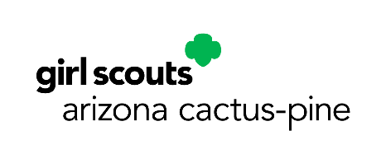
Date

Name of Store
Store Address
Store telephone number

Attention: Store Manager

RE: Girl Scouts–Arizona Cactus-Pine Council, Inc.
86-0133397
Troop Number

Dear Mr. or Ms. XXXX:

There’s more to the annual Girl Scout Cookie Program than just a great cookie! The skills and confidence girls build by participating in the cookie program is priceless. When a Girl Scout sells cookies, she is creating a plan, interacting with customers, and working as part of a team. She is building a lifetime of skills and confidence.

Selling cookies teaches her goal setting, decision making, money management, people skills, and business ethics—aspects essential to leadership, to success, and to life. It empowers her with the strength, abilities, and the drive to become an accomplished woman who benefits herself, her family, and the world.

Girl Scout Cookie Booths are essential for this program to be successful. Please support the Girl Scout Cookie Program and Girl Scouting by allowing Troops to host a booth at your store site. Our Cookie sale is the financial literacy program for Girl Scouts and provides the funding to over 24,000 girl members. Your support is vital to the success of the program.

Troop XXXX requests a booth at the time listed below.

- Include dates and times

Thank you for supporting the Girl Scouts and our local community.

Sincerely,

Troop Leader’s name
Troop number
Girl Scouts–Arizona Cactus-Pine Council, Inc.
Phone number
Email address

